
SPEAKERS FORM
First name | Sheena
Last name | Bell
Picture | 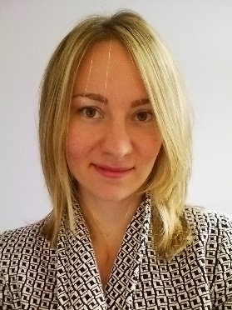
Title | Regional Education Specialist
Establishment | UNICEF Europe and Central Asia Regional Office
Establishment  Profile | UNICEF promotes the rights and wellbeing of every child, in everything we do. Together with our partners, we work in 190 countries and territories to translate that commitment into practical action, focusing special effort on reaching the most vulnerable and excluded children, to the benefit of all children, everywhere.
Biography | Sheena Bell is the Regional Education Specialist at the UNICEF Europe and Central Asia Regional Office, based in Geneva. She is responsible for supporting the education programmes of the 21 UNICEF country offices in the region. Previously, she worked in the Education Indicators and Data Analysis Section of the UNESCO Institute for Statistics, based in Montreal, Canada. There she was focal point on out-of-school children data and analysis, and was part of the global team supporting the Global Initiative on Out-of-School Children. This is a joint initiative by UNICEF and UNESCO to accelerate efforts to reduce the number of out-of-school children in more than 30 countries worldwide, through developing studies which included new and improved methods to analyse and use data and research on out-of-school children.  Sheena has a Master’s degree in Political Science from McGill University, and a Master’s Degree in Public Administration – International Development from the University of York. She is a Canadian national.
Presentation content | The presentation will provide an overview of UNICEF’s work in education and literacy. It will provide a global context for education currently, explain UNICEF’s key priorities and ways of working, and then provide some examples of UNICEF’s work. This will include Education activities in the Europe and Central Asia region, as well as the longstanding and best practice example of the UNICEF partnership with Mont Blanc.
Presentation date | 14 September 2017
Contact details | sbell@unicef.org  +41 22 909 5534
Member name

Meeting at Hotel Intercontinental, Thursday 18h30-20h00.Conferences start at 19h, long 20’+ Q&A

