SPEAKERS FORM
First name | Jean-Philippe
Last name | Vial
Picture | 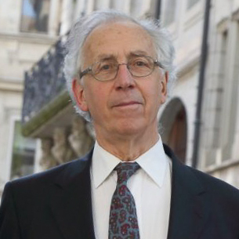
Title | Professor (Emeritus)
Establishment | University of Geneva  Agua Para la Vida Nicaragua https://aplv.org/
Establishment  Profile | Agua Para La Vida is a small NGO aiming at bringing clean water to small poor rural communities in Nicaragua. APLVN uses a holistic approach: apart from the design and construction of the water distribution system, its projects also include the construction of latrines and the strengthening of local capacities through training on administration, operation and maintenance of the water system, health and environmental education and integrated water resources management. APLV also created the Potable Water Technical School for young people from rural communities. Finally, APLV has developed innovative design software to meet the special features of robust gravity-fed water distribution systems.
Biography | Jean-Philippe Vial holds a PhD in Mathematics from Paris University. He served as Professor in Operations Management and Logistics in several Universities (Louvain, Berkeley, Strasbourg, Geneva). He has a long-standing interest for development problems: He joined APLV-France board in 2002. He lead the collaborative development project between APLV and the University of Geneva  on NeatWork, the main software for gravity-fed water distribution systems.
Presentation content | Water and sanitation access in Nicaragua, a so a so far unresolved problem.  Agua Para La Vida: methodology of intervention and achievements.  Past collaborations between Rotary Clubs and Agua Para La Vida.  Perspectives for a new collaboration.
Presentation date | 29.03.2018
Contact details | jphvial@gmail.com
Member name | Gavin Taylor

Meeting at Hotel Intercontinental, Thursday 18h30-20h00.Conferences start at 19h, long 20’+ Q&A

